**Code - X** – An action packed two-player VR game. Survive with your companion, maintain your humanity and escape becoming a feast among the dead.

**Prologue**

By 2050, artificial intelligence far exceeds mankind's. With great intent, the creators of Eris, the worlds most advanced AI system was programmed to resolve what humanity continues to struggle with, famine, war, disease and inequality.

In an unexpected succession of events, Eris’ answer is to sift through humanity and do away those who hold her from utopia.

Set in an underground complex, home to her experimental test subjects. Eris executes her 4-stage project:

1. Physical agility

2. Mind game

3. Cooperation

4. Emotion

**Control:**

Code-X requires Samsung Gear VR and touch pad controller.

**Mechanics:**

The game tests their ability to follow tasks, find clues (in true Sherlock style) and cooperate together in a whole new level to escape through the next level. There are twists and turns within the storyline in an attempt to take the players off course and loose hope. Both will require their mental agility whilst able to fight off what’s around the corner. Failure for both players to survive will result in the termination of the game. All in all designed to make this game more of a thrilling and unique experience.

**Innovation:**

The game design is centred upon real world Escape Room games, based upon attractive or popular themes. To escape will require players to solve puzzles in true Sherlock style.

The significant weaknesses far outweigh the benefits in real world scenarios. Cost is the biggest factor to failure. Second, few locations to play. Third, the types of puzzles are limited and at times boring. All the weaknesses can be resolved and enhanced in Gear VR. To experience the impossible in the real world and to achieve a far superior and immersive feel.

“Code-X” is the first theme of a series, designed for our VR escape room game.

**Getting started:**

This is a two-player game. Both players must download our “apk” and install on Galaxy Note 4.

Upon starting, follow the UI first before placing in VR headset:



Player 1 should choose “Start Server”. Player 2 should choose “join escape”. Following the pairing process, both players will join the game and be able to see one another at base.

Then, you can place your Galaxy Note 4 in Gear VR. Use your touch pad controller to experience the game.

The functions of the touch pad controller are illustrated below:

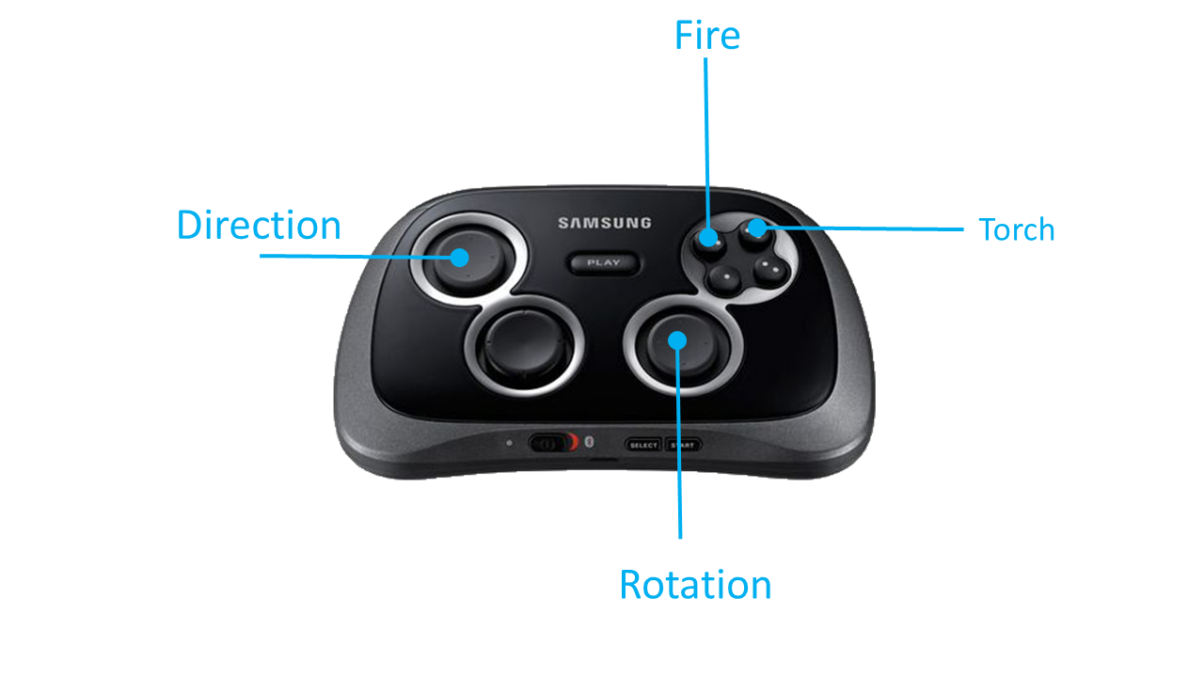

**Techniques:**

* Photon Unity 3D Networking Frameworks SDKs to implement our multiplayer function.
* Serial work are completed in Photon in order to make multiplayers have the same view in the game.
* Design Enemy AI system to make the enemies work more intelligently.
* Implement holographic effects to make the scene meet our game theme (Sci-Fi).
* Use No Touch GUI for VR to give players more interactive ways of manoeuvring within the game.
* Orchestrated all music within the game to enhance immersion.